

**INTERNET PAYMENT GATEWAY**

**MERCHANT ADMINISTRATION-USER GUIDE**

**How to create an operator in Merchant Administration**

**\*URL for logging in to Merchant Administration (Test)**

<https://test-bankofceylon.mtf.gateway.mastercard.com/ma/login.s>

* To use Merchant Administration, you need,

1. Your Merchant ID - 700193990120

2. Your Administrator ID- administrator

3. Corresponding password – Boc12@34

* To log in to **Merchant Administration Login**:

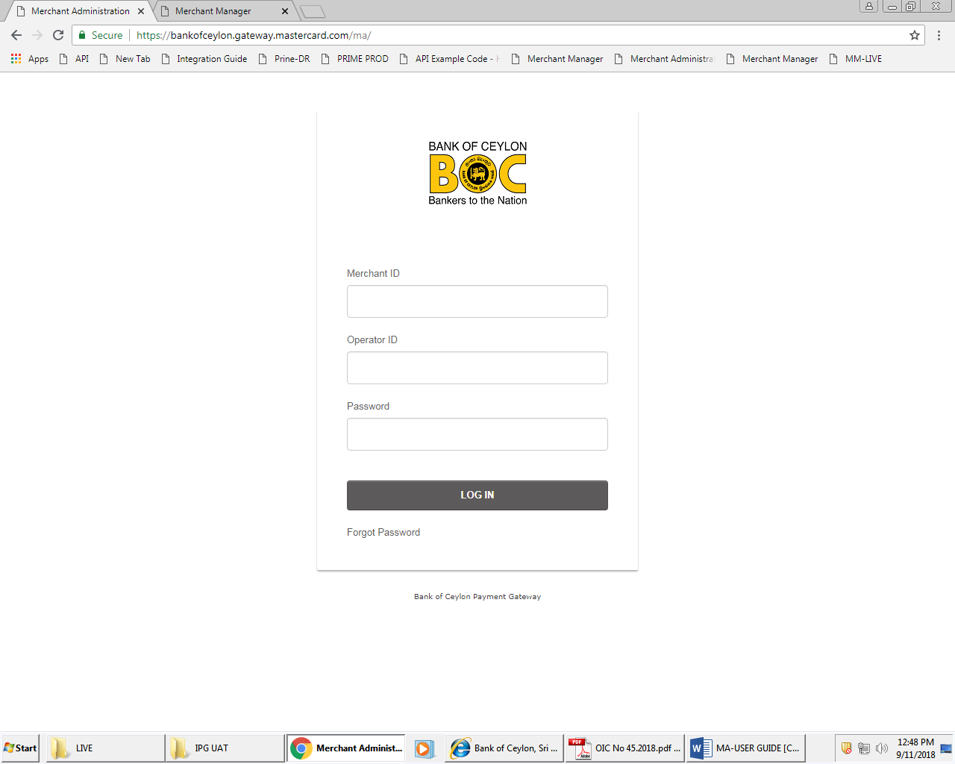

1. Enter your Merchant ID

2. Enter your Operator ID

3. Enter your Password

4. Click LOG IN. The Merchant Administration home page is displayed.

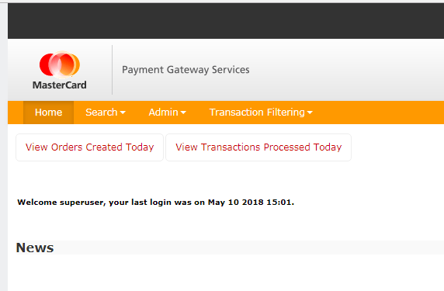

* Upon Login, navigate to the “Admin” Tab, and Select Operators.

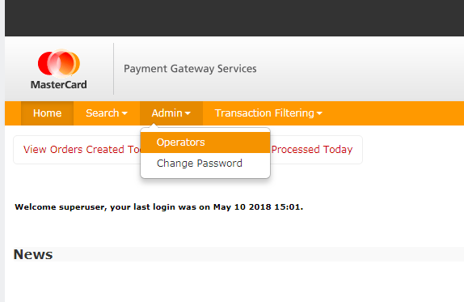

* Click “Create a New Merchant Administration Operator”

**\*\*\*The reason why an operator needs to be created is because administrator is not designed to perform operating tasks such as refund/void. Furthermore only operator can generate API Password for API integration and reporting API password.**

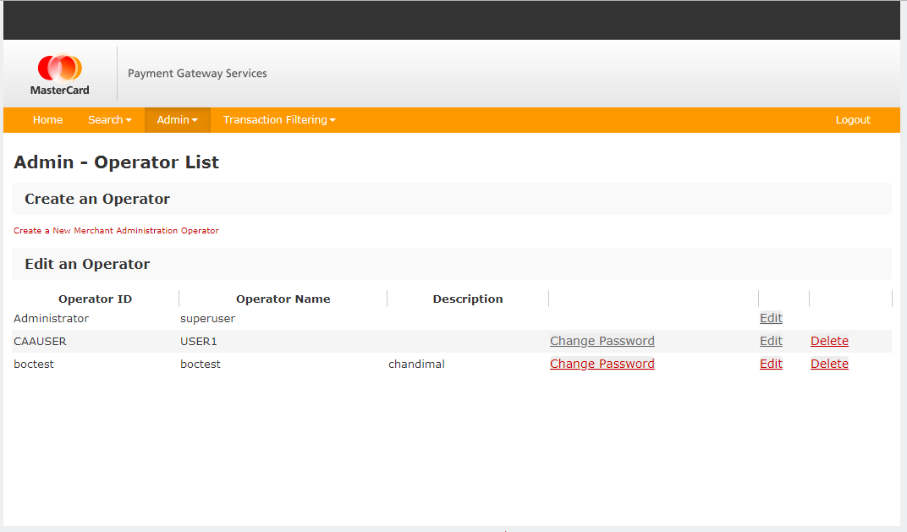

* You may now create an operator account.

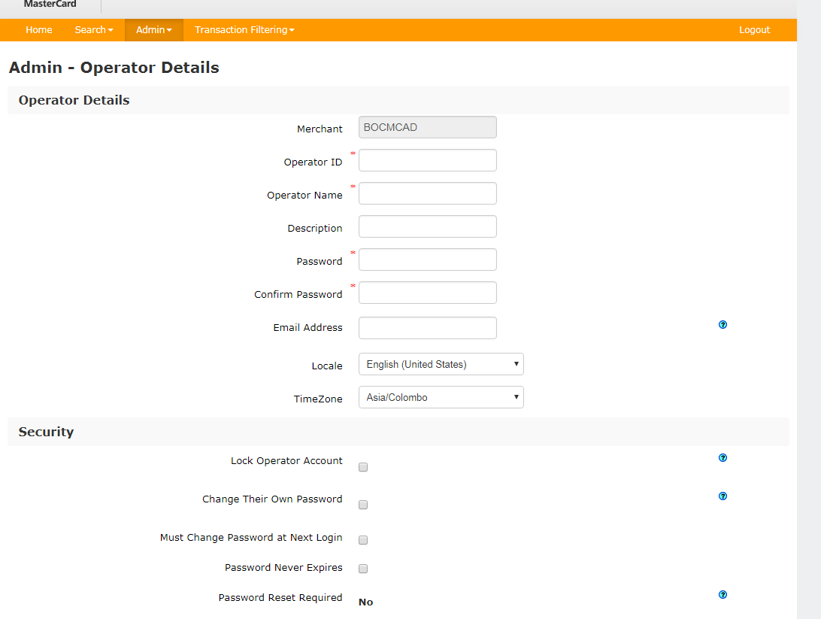

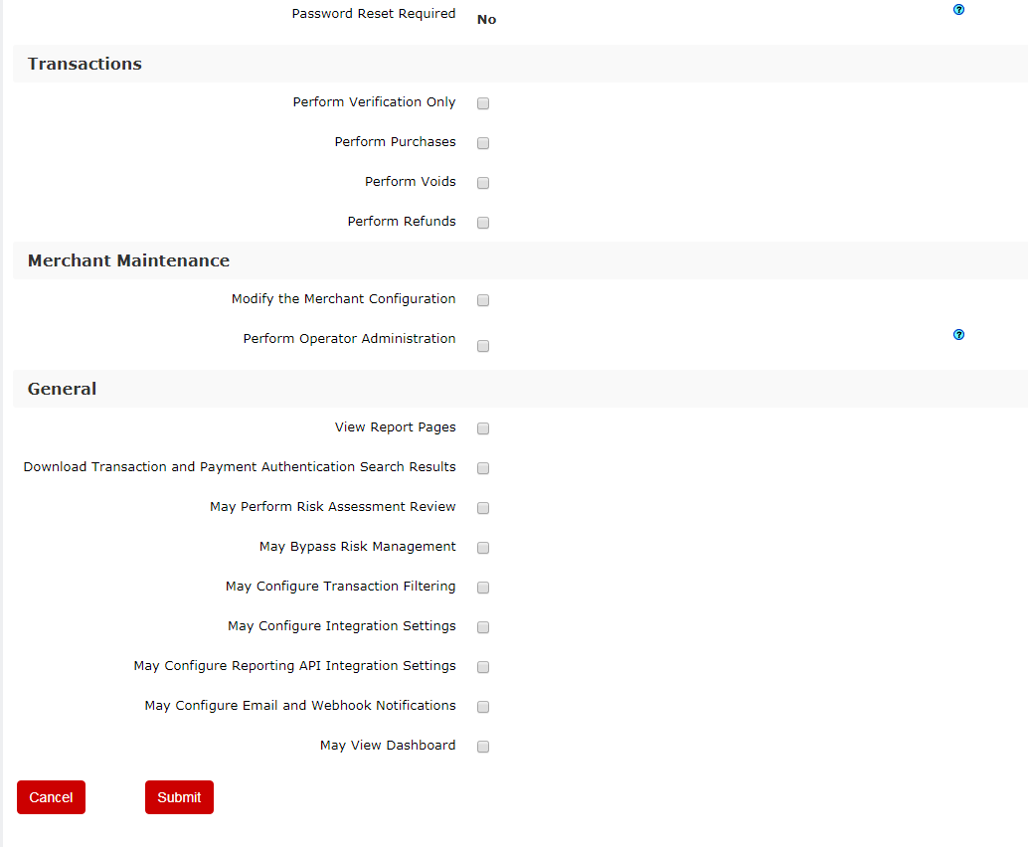

The Merchant Administration Login screen requires the following information. You should fill the login screen fields according to the values you given under the section "Operator Details".

|  |  |
| --- | --- |
| **Field** | **Description** |
| Merchant ID | The merchant’s unique alphanumeric identifier provided with each merchant account/profile. |
| Operator ID | The operator ID. |
| Password | Must be at least eight characters long, contain at least one alphabetical character and numeric character and is case-sensitive. |

* To perform transactions, the merchant would require our API integration. To generate the same please ensure the below highlighted fields are selected for your operator to generate the corresponding password upon login.

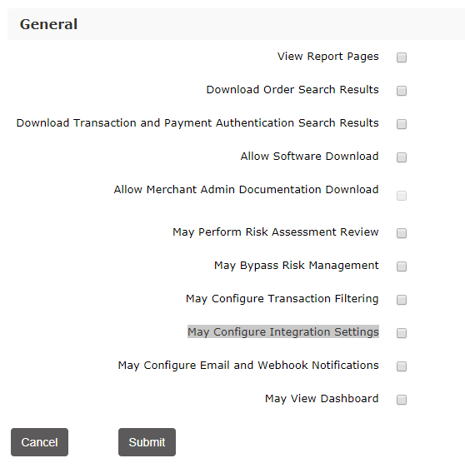

**How to Obtain the Merchant’s API Credential**

**\*URL for logging in to Merchant Administrator**

<https://test-bankofceylon.mtf.gateway.mastercard.com/ma/login.s>

* Please ensure the merchant is using the operator account to access the MA Portals.



* Upon Login, Please navigate to the “Admin” Tab, and Click “Integration Settings”.

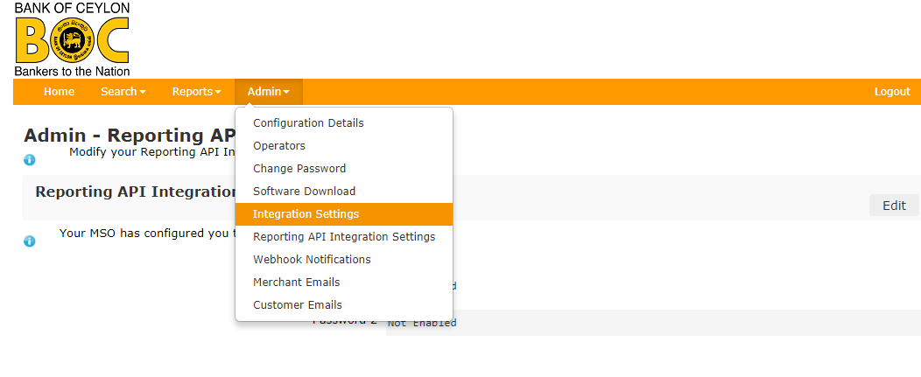

* **Please click “Edit> Generate New"**

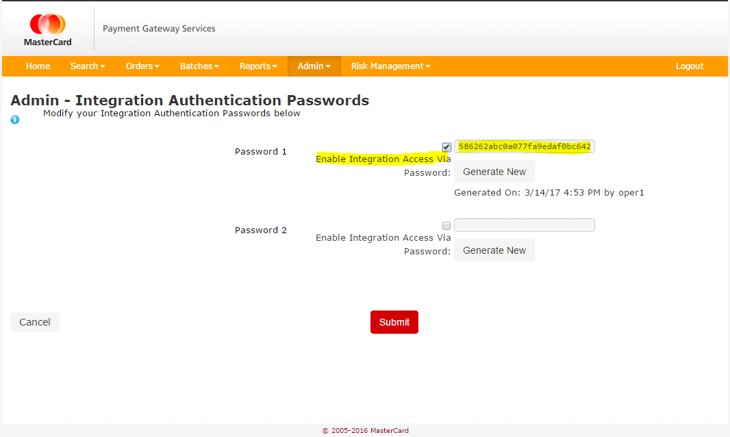

* **Please ensure the newly generated password, appears besides "Password 1" and click submit.**

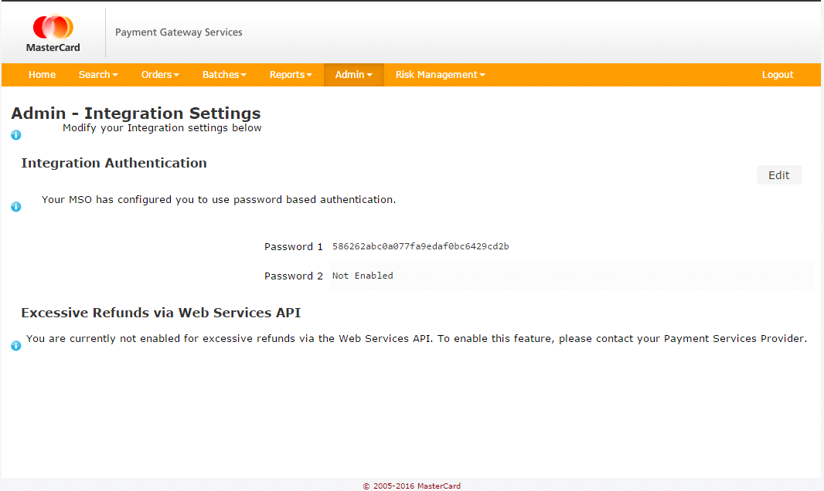

* **Once you submit the generated API password it will be saved under Admin- Integration Settings.**

**Bank of Ceylon. Proprietary. All rights reserved.**

**Internet Payment Gateway-Merchant Administration User Guide**